|  |
| --- |
| **ZooTracker** |
|  |
| Technical Specifications |

|  |
| --- |
| **Authors**  TIKramer |
|  |
|  |
| **Date** |
| 24/06/2016 |
|  |
| **Version** |
| 0.1 |

Table of Contents

1 **Introduction** 4

1.1 Revision History 4

1.3 Project Scope 4

2 Project Description 5

2.1 Product Perspective 5

2.2 Product Features 5

2.3 Operating System 5

2.4 Constraints 5

2.5 User Documentation 5

3 Functional Requirements 6

NonFunctional Requirements 8

4 External Interface Requirements 8

4.1 User Interface 8

4.2 Hardware Interface 8

4.3 Software Interfaces 8

5 Nonfunctional Requirements 9

5.1 Performance Requirements 9

5.2 Safety Requirements 9

5.3 Security Requirements 9

5.4 Software Quality Attributes 9

6 Other Requirements 9

6.1 Data Requirements 9

Appendix A: Glossary 11

# 1 **Introduction**

## 1.1 Revision History

|  |  |  |  |
| --- | --- | --- | --- |
| **Date** | **Authors** | **Reason** | **Version** |
| **24/06/2016** | TIKramer | First Draft | 0.1 |

## 1.3 Project Scope

The goal of the ZooTracker application is to assist zoo staff in getting storing and maintaining details about the animals, enclosures and events at the zoo.

The software will be made available on Android platforms.

# 2 Project Description

## 2.1 Product Perspective

## 2.2 Product Features

## 2.3 Operating System

Any phone that supports the Android operating system version 4.0 (Ice Cream Sandwich) or greater will be able to install the application and run the application from their device.

## 2.4 Constraints

## 2.5 User Documentation

# 

# 3 Functional Requirements

|  |  |  |  |
| --- | --- | --- | --- |
| **ID** | **Name** | **Description** | **Priority** |
| 1.0 | Android Application | The ZooTacker will be developed for Android | High |
| 1.1 | Android Version | Targeting the 23rd API and having the minimum requirement of the 15th API of the Android operating system. | High |
| 2.0 | Adding animals | Users of the application will be able to add a new animal with the animal’s details. These animals are then stored in the application. | High |
| 2.1 | Edit animals | Users of the application will be able to edit the deatils of an exsiting animal. These animals are then updated in the storage in the application. | High |
| 2.2 | Remove Animals | Users of the application will be able to remove an exsiting animal. These animals are then removed from the storage in the application. | High |
| 3.0 | Adding enclosures | Users of the application will be able to add new enclosures with enclosure details. Enlosures must belong to an animal type. These enclosures are then stored in the application. | High |
| 3.1 | Edit enclosures | Users of the application will be able to edit exsiting enclosures details. These enclosures are then updated in the storage of the application |  |
| 3.2 | Remove enclosures | Users of the application will be able to remove exsiting enclosures. Animals who live in that enclosure must be moved somewhere before an enclosure can be delted. These enclosures are then removed from the storage in the application. | High |
| 4.0 | Adding feeding times | The user will be able to add feeding times for an animal. | High |
| 4.1 | Edit feeding times | The user will be able to edit feeding times for an animal | High |
| 4.2 | Remove feeding times | The user will be able to remove feeding times for an animal | High |
| 4.0 | Adding event times | The user will be able to add events | High |
| 4.1 | Edit event times |  | High |
| 4.2 | Remove event times |  | High |
| 4.0 |  |  | High |
| 4.1 |  |  | High |
| 4.2 |  |  | High |
| 4.0 |  |  | High |
| 4.1 |  |  | High |
| 4.2 |  |  | High |

# 

# NonFunctional Requirements

|  |  |  |  |
| --- | --- | --- | --- |
| 1.0 | Simple Ui | Any zoo employee will be able to use the application without too much training. | High |
|  |  |  |  |

# 4 External Interface Requirements

## 4.1 User Interface

The UI will be designed to be simple and intuitive so that any zoo employee will be able to use the application without too much training. The UI will be designed, where possible, to the current standards set forth by Google.

## 4.2 Hardware Interface

## 4.3 Software Interfaces

Android operating system version 4.0 (Ice Cream Sandwich) or greater will be needed to install the application and run the Android application from their device.

# 5 Nonfunctional Requirements

## 5.1 Performance Requirements

## 5.2 Safety Requirements

## 5.3 Security Requirements

## 

## 5.4 Software Quality Attributes

# 6 Other Requirements

## 6.1 Data Requirements

7. Diagrams

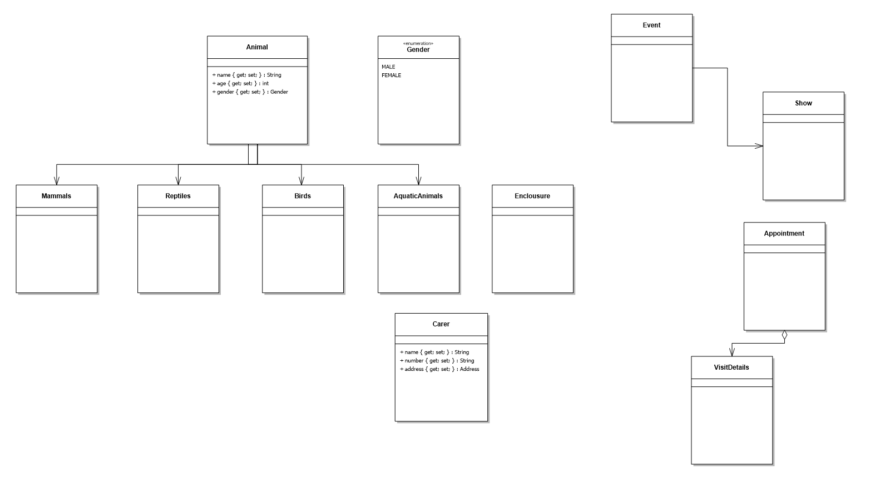

# Appendix A: Glossary

|  |  |
| --- | --- |
| **Term** | **Description** |
| UI | User Interface |
|  |  |
|  |  |